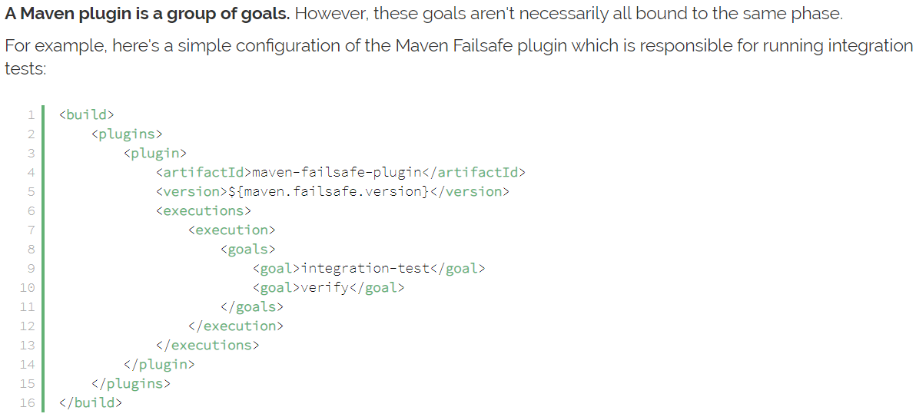

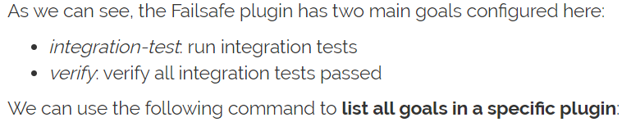

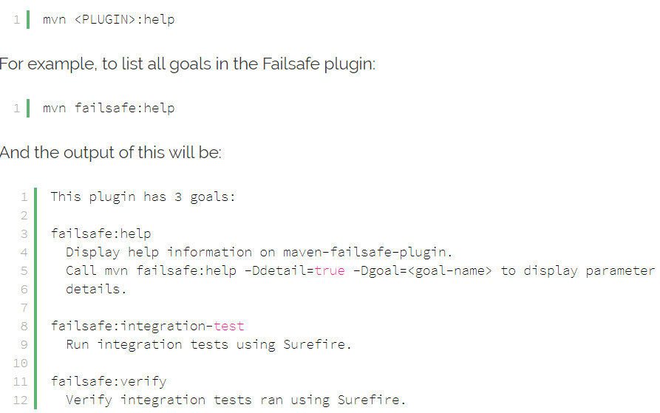

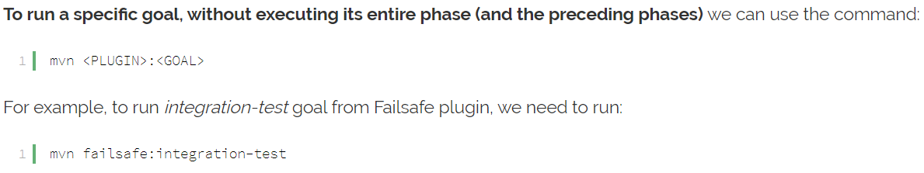

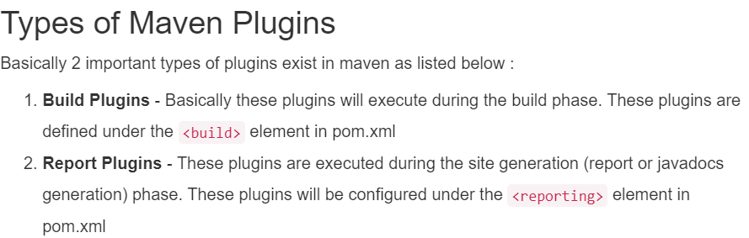

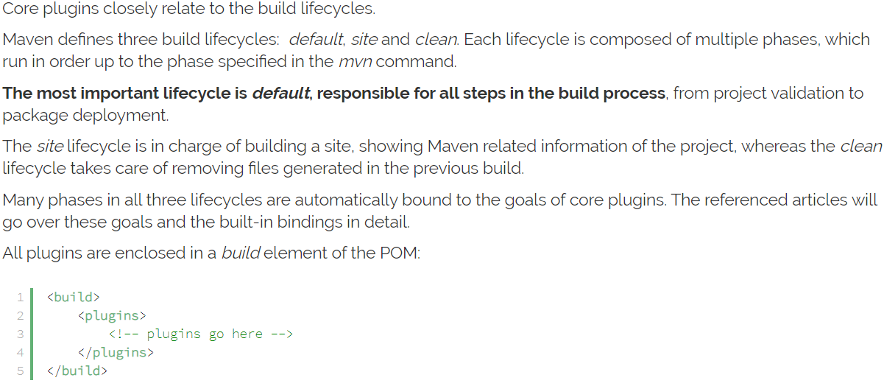

**Default plugin details:**

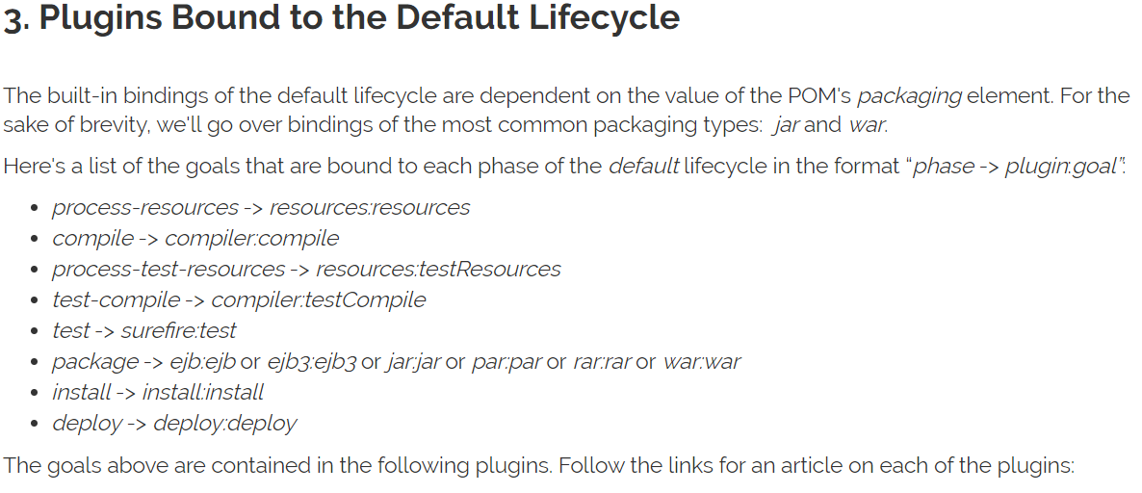

**Resource plugin:**

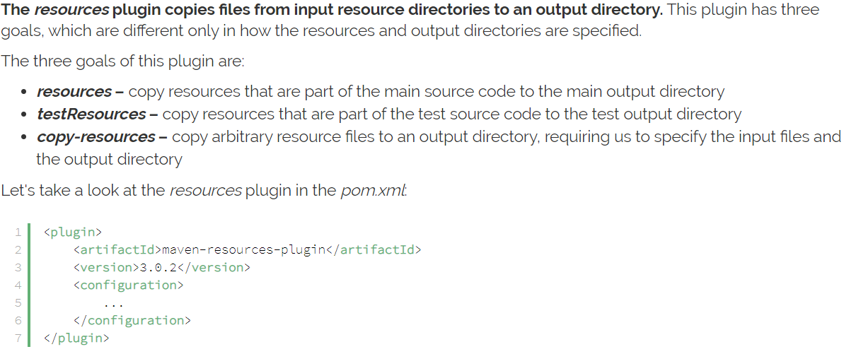

**Example:**

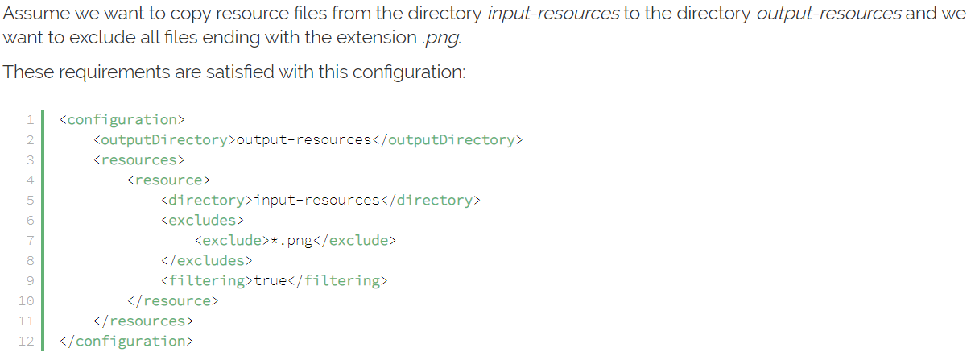

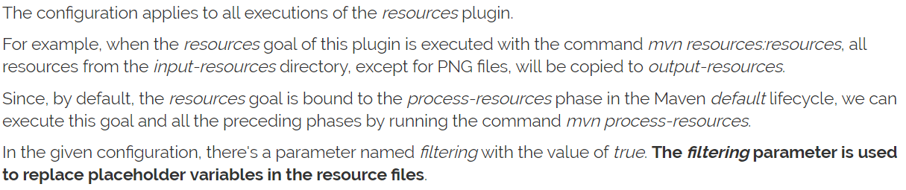

**Compiler plugin:**

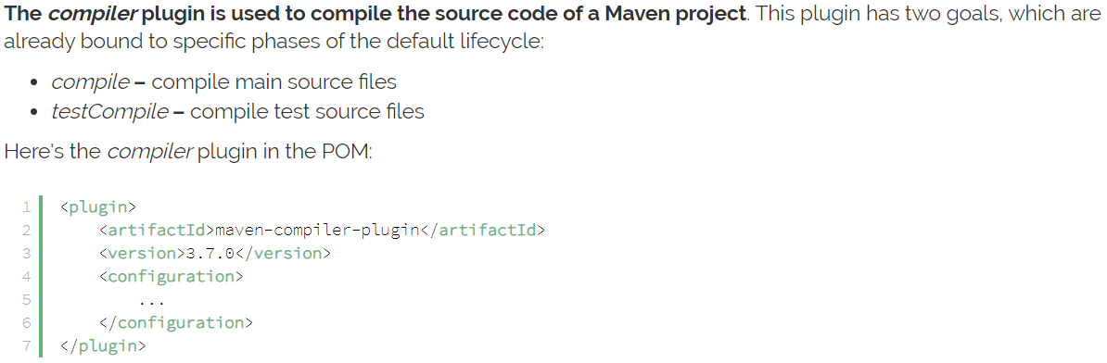

**Surefire plugin:**





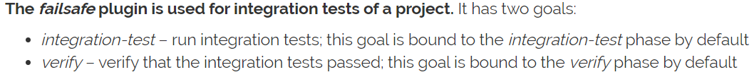

**failsafe plugin:**

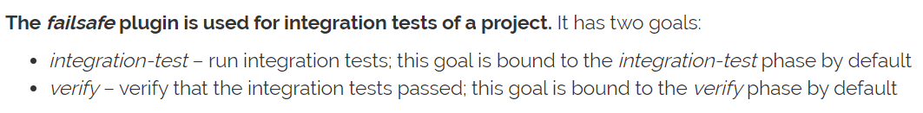

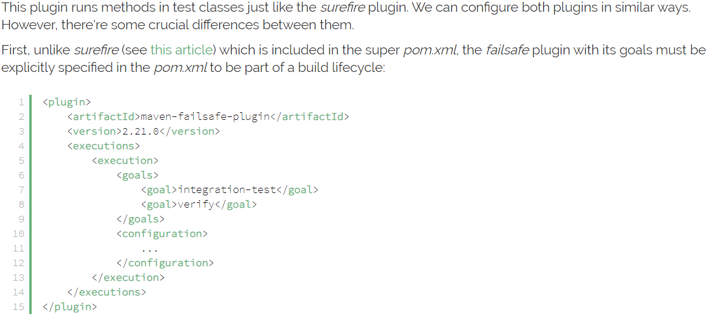

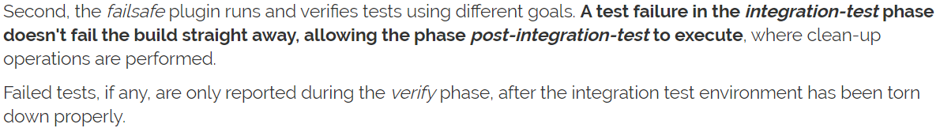

**Verifier plugin:**



**Install plugin:**

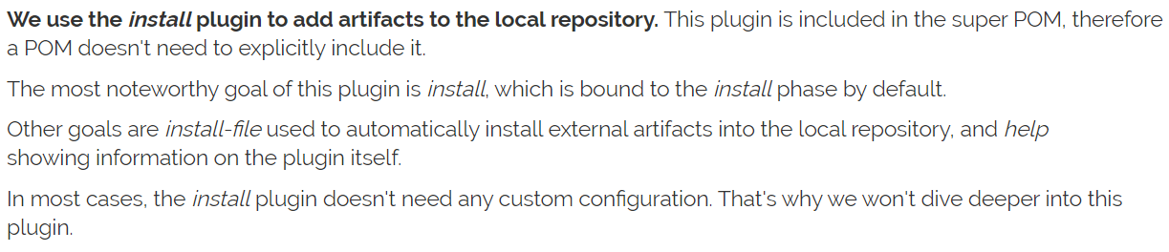

**Deploy plugin:**

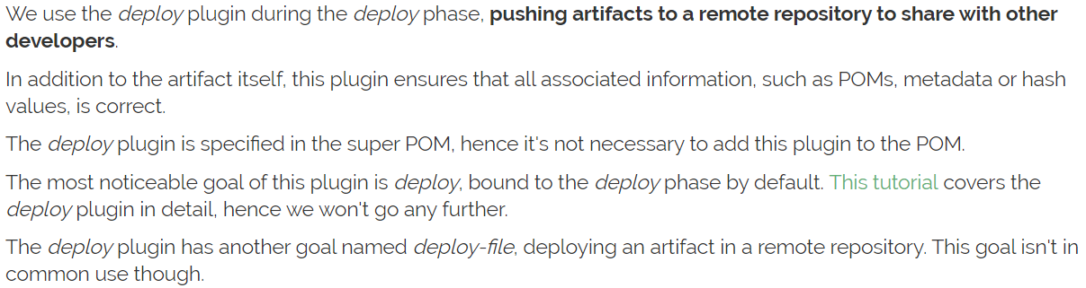

**Site plugin:**

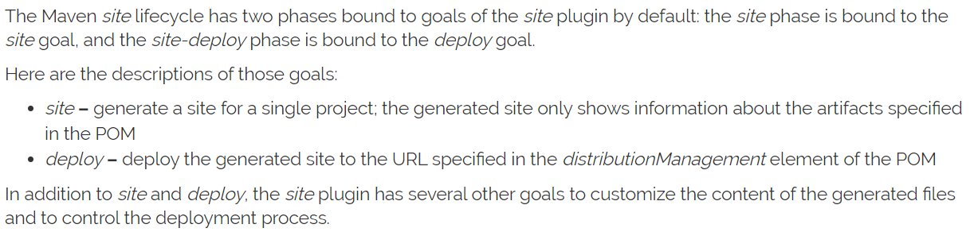

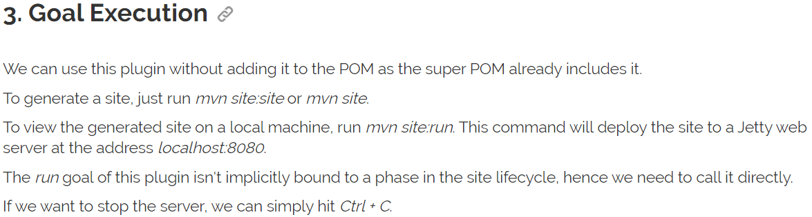

**Clean plugin:**

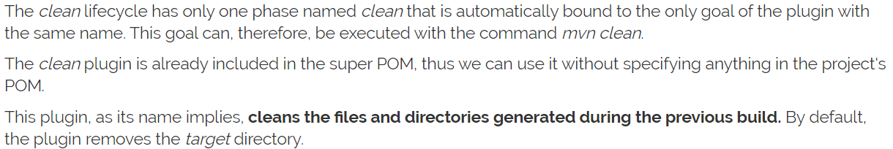

We can also configure the directories which needs to be cleaned. We can also make the modifications in all the plugins

Below is the link to refer for more information

<https://www.baeldung.com/core-maven-plugins#maven-build-lifecycles>

below is the link on how to create plugins

<https://www.baeldung.com/maven-plugin>

**Build task:**

* Inside build, we have plugins, these plugins define what we want apart from maven lifecycle
* Those plugins we need to download and make use of it
* Any external tasks can be done with the plugins
* If we want to execute the jar file which not included in default maven life cycle, we need to download the plugins and use it under build task, need to make some changes in plugins
* These plugins, we can’t run it with default life cycle, we need to do pass this plugin command explicitly
* Use the below command for that
* **Mvn exec:java**
* **Mvn package exec:java (use this, if we want to create the package)**
* By running the command, it executes only the plugins but not the maven life cycle